

**CSE 240 Data Science with R**

**STUDENT WORK BOOK**

|  |  |  |
| --- | --- | --- |
| **Name** | **:** | M SIVANT |
| **Unique ID** | **:** | E00119004 |
| **Year** | **:** | II |
| **Quarter** | **:** | Q6 |
| **Department** | **:** | B.Tech CSE (CyS & IoT or AI &ML) |
| **Faculty Name** | **:** | Prof.B.Nirmala or Prof.N.Chiranjeevi |
| **Academic Year** | **:** | 2020-2021 |

**Date: 02-11-2020**

**Questions:**

1.Consider 2 vectors c(9,10,11,12) and c(13,14,15,16). Create a 4 by 2 matrix from these two vectors

2.Write an R program to take input from the user (user ID and Group/Branch) and display the values

3. Create a data frame Write a R program to create a data frame from four given vectors. a name b. Subject C. Score d. Rank

4.Write a R program to get the statistical summary and nature of the data of a given data frame. (use 3rd Question dataframe)

5. Write a R program to extract specific column from a data frame using column name

6. Write a R program to extract first two rows from a given data frame

**Program:**

# question 1

cat("Creation of Matrix:\n\n")

a <- c(9,10,11,12)

b <- c(13,14,15,16)

matrix_4_by_2 <- matrix(data = c(a,b), nrow = 4, ncol =2)

print(matrix_4_by_2)

# question 2

cat("\nGetting input from the user:\n\n")

id = readline("Enter userID : ")

batch = readline("Enter batch : ")

cat(id, batch,'\n')

# question 3

cat("\nCreating a dataframe:\n\n")

name = c("Siva","King","Star")

subject = c("AI & ML","Python","IOT")

score = c(19,20,18)

rank = c(2,1,3)

df = data.frame(name, subject, score, rank)

print(df)

# question 4

cat("\nDisplaying summary:\n\n")

print(summary(df))

# question 5

cat("\nDisplaying name column of the dataframe:\n\n")

print(df['name'])

# question 6

cat("\nDisplaying 1st two rows of the dataframe:\n\n")

print(df[1:2,])

**Output:**

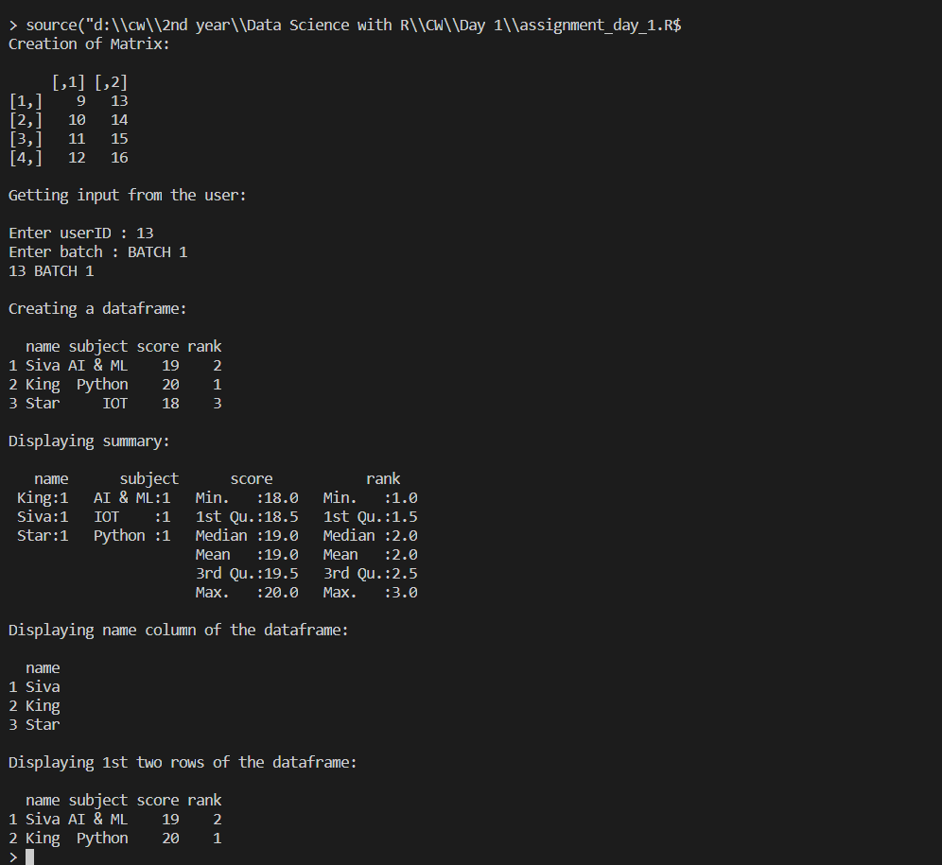

**Explanation: Concept or Program**

1. Vector:

Vector is a collection of elements

**Syntax** = c (val1, val2, val3, …, valn)

1. Matrix:

Matrices are the R objects in which the elements are arranged in a two-dimensional rectangular layout.

**Syntax** = matrix(data, nrow, ncol, byrow, dimnames)

1. DataFrame:

A data frame is a table or a two-dimensional array-like structure in which each column contains values of one variable and each row contains one set of values from each column.

**Syntax** = data.frame(column1, column2, …, columnn)

1. Summary:

The statistical summary and nature of the data can be obtained by applying summary() function.

**Syntax** = df.summary()

1. as.numeric(val):

as.numeric() is used to convert variable val to numberic type

1. print():

print() is used to display a message or value stored in a variable

1. cat():

cat () is used to concatenate 2 or more messages or values stored in a variable and finally display the values at the console

1. slicing:
   1. df['name']: display specific column in a data frame
   2. df[1:2,]: display first two columns in a data frame

**Date: 03-11-2020**

**Questions:**

1.Create an R script that calculates the square root of a given integer vector x of length one, if the value contained in x is negative it should return NA.

2. Demonstrate and examine the output of letter and LETTER

3.Create an R script that, given a numeric vector x with length 3, will print the elements by order from high to low.

4.Create an R script that returns the amount of values that are larger than the mean of a vector. You are allowed to use mean(). ( Use function)

5.Write a double for loop which prints 30 numbers (1:10, 2:11, 3:12). Those are three clusters of ten numbers each. The first loop determines the number of clusters (3) via its length; the second loop the numbers to be printed (1 to 10 at the beginning). Each cluster starts one number higher than the previous one

6 a. You have the data.frame ‘mydf’ with four columns like below

a = c(3,7,NA, 9)

b = c(2,NA,9,3)

f = c(5,2,5,6)

d = c(NA,3,4,NA)

You want to add another column ‘5’: the 5th column contains the value of col 2 if col 1 is NA; the 5th column contains the value of col 4 if col 2 is NA; the 5th column contains the value of col 3 in all other cases.

7.Write a while loop starting with x = 0. The loop prints all numbers up to 35 but it skips number 7. Condition: If x== 7 next

8. Examine the difference between typeof and class () method using R program

9. Create a function and demonstrate their features like required, keyword, default.

10. Create a dataframe and delete the row and column. (Use the own data values to create frame)

**Program:**

# question 1

cat("Square root of a number:\n\n")

x = as.integer(readline("Enter a number : "))

if(x>=0){

    print(paste("Square root = ",sqrt(x)))

}else {

   print(NA)

}

cat('\n')

# question 2

cat("\nletters vs LETTERS:\n\n")

print(letters) # lower case constant

print(LETTERS) # upper case constant

cat('\n')

# question 3

cat("\nDisplay values max to min:\n\n")

vector = c(13, 1, 6)

print(sort(vector,decreasing = TRUE))

cat('\n')

# question 4

cat("\nDisplay values greater than mean:\n\n")

values = c(1:10)

mean_value = mean(values)

cat("MEAN : ",mean_value,'\nVALUES GREATER THAN MEAN : ')

for(i in values)

    if(i>mean_value)

        cat(i,' ')

cat('\n')

# question 5

cat("\nDisplay sequence of numbers:\n\n")

for(i in seq(1:3)){

    for(j in seq(i,i+9))

        cat(j,' ')

    cat('\n')

}

# question 6

cat("\nAdd a vector to dataframe:\n\n")

df = data.frame(

    a = c(3, 7, NA, 9),

    b = c(2, NA, 9, 3),

    f = c(5, 2, 5, 6),

    d = c(NA, 3, 4, NA)

)

e = c()

print(df)

cat('\n')

for(i in 1:nrow(df))

    if(is.na(df[i,1])){

        e = c(e,df[i,2])

    }else if (is.na(df[i,2])){

        e = c(e,df[i,4])

    }else{

        e = c(e,df[i,3])

    }

df = cbind(df,e)

print(df)

cat('\n')

# question 7

cat("\nDisplay numbers from 0 to 35 except 7:\n\n")

for(i in seq(0,35))

    if (i==7) {

       next

    }else {

        cat(i,' ')

    }

cat('\n')

# question 8

cat("\nTypeof vs class:\n\n")

a = 1L; b = 'a'; c = pi; d = c(1,2,3)

print(typeof(a))

print(typeof(b))

print(typeof(c))

print(typeof(d))

print(class(a))

print(class(b))

print(class(c))

print(class(d))

# question 9

cat("\nRequired, Keyword and Default:\n\n")

# required

square = function(num){

    print(seq(1,num)^2)

}

square(5)

cat('\n')

# keyword

even_or_odd = function(val){

    if(val%%2==0)

        return ('EVEN')

    else

        return ('ODD')

}

print(even_or_odd(val=13))

cat('\n')

# default

hello <- function(name = 'buddy',age=18){

    print(paste("Hello",name,",you are",age,"years old!"))

}

hello()

hello("siva",13)

cat('\n')

# question 10

cat("\nDelete row and column:\n\n")

print(df)

cat('\n')

# delete row

print(df[-c(1,4),])

cat('\n')

# delete column

print(subset(df, select = -c(a,d)))

cat('\n')

**Output:**

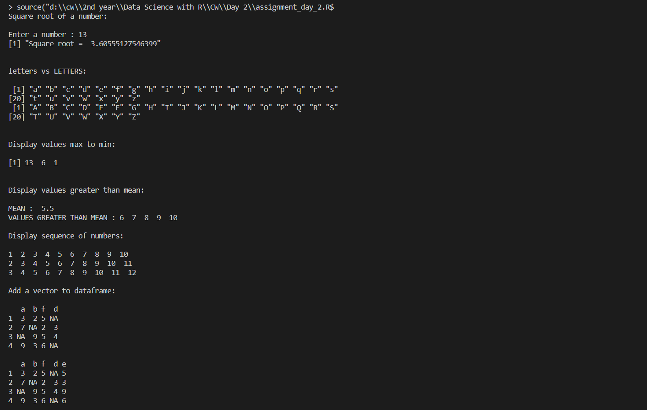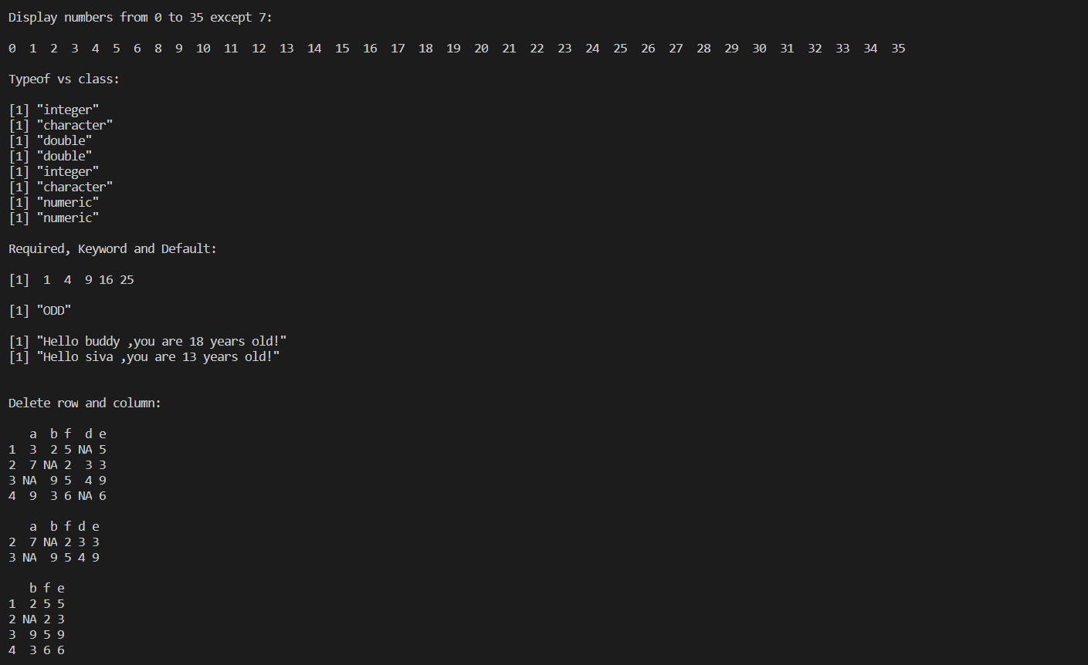

**Explanation:**

1. sqrt():

sqrt() is an inbuilt function which returns square root of a number

1. letters and LETTERS:

letters and LETTERS are constants built in R

* 1. LETTERS: the 26 upper-case letters of the Roman alphabet
  2. letters: the 26 lower-case letters of the Roman alphabet

1. sort():

Sort (or order) a vector or factor (partially) into ascending or descending order.

1. mean():

Find mean for an array of elements

1. is.na():

returns true if the value of an element is NA

1. while():

It tests the condition before executing the loop body.

**Syntax:** while(condition) {

statements

}

1. for():

it tests the condition at the end of the loop body.

**Syntax:** for (value in vector) {

statements

}

1. if-else statements:

An if statement can be followed by an optional else statement which executes when the Boolean expression is false.

**Syntax:** if(Boolean expression) {

// statement(s) will execute if the Boolean expression is true.

} else {

// statement(s) will execute if the Boolean expression is false.

}

1. next:

next is used to continue the existing loop

1. class():

The function class prints the vector of names of classes an object inherits from.

1. typeof():

typeof() determines the (R internal) type or storage mode of any object.

1. function():

A function is a set of statements organized together to perform a specific task.

**Syntax:** function_name <- function(arg_1, arg_2, ...) {

Function body

}

1. cbind():

cbind() function combines vector, matrix or data frame by columns. The row number of the two datasets must be equal. If two vectors do not have the same length, the elements of the short one will be repeated.

**Syntax:** cbind(x1, x2)

x1, x2 can be vector, matrix or data frame

1. subset():

Subset Function in R, returns subset of data frame, vectors or matrices which meet the specified conditions.

**Syntax:** subset(x, condition, select)

* x – can be a matrix ,data frame or vector
* condition- condition to be satisfied
* select – columns to be selected

1. paste():

Paste function in R is used to concatenate Vectors by converting them into character.

**Syntax:** paste (arg1, arg2, sep = “”, collapse = NULL)

1. seq():

seq() function in R generates a sequence of numbers

**Syntax:** seq(from, to, by, length.out)

* From beginning of the sequence
* To end of the sequence
* By increment by (default is 1)
* length.out length of the sequence

**Date: 04-11-2020**

**Questions:**

1.Write a function that turns (e.g.) a vector c("a", "b", "c") into the string "a, b, and c". Think carefully about what it should do if given a vector of length 0, 1, or 2.

2. Consider a data frame df:

Id=c(1:10)

Age=c(14,12,15,10,23,21,41,56,78,12)

Sex=c('F','M','M','F','M','F','M','M','F','M')

Code=letters[1:10]

df=data.frame(Id,Age,Sex,Code)

Create a function that, given a data frame and two indexes, exchanges two values ​​of the Code variable with each other.

For example, if the index is 1 and 3, you assign:

df[1,'Code']=df[3,'Code']

df[3,'Code']=df[1,'Code']

3.Create a function that given a numeric vector, sort this in ascending order and duplicate it by two.

4.Create a function that given a numeric vector X returns the digits 0 to 9 that are not in X. If X=0 2 4 8 the function return 1 3 5 6 7 9

5.Create a function that given one word, return the position of word’s letters on letters vector. For example, if the word is ‘abc’, the function will return 1 2 3.

6. Write a code to check the given string is anagram or not

**Program:**

# question 1

cat('\nVector to String\n\n')

to_string = function(vector){

    if (length(vector)==0){

      return("NA")

    }

    else if(length(vector)<2){

      return(as.character(vector))

    }else{

        value = paste(vector[1:length(vector)-1],collapse=', ')

        return(paste(value,'and',vector[length(vector)]))

    }

}

print(to_string(c()))

print(to_string(c(1)))

print(to_string(c(1,2)))

print(to_string(c(1,2,3,4)))

cat('\n')

# question 2

cat('\nSwap Code\n\n')

swap_code = function(df,a,b){

  if(a<=nrow(df) && b<=nrow(df)){

    temp = df[a,'Code'];

    df[a,'Code']=df[b,'Code']

    df[b,'Code']=temp

    print(df)

  }

}

Id=c(1:10)

Age=c(14,12,15,10,23,21,41,56,78,12)

Sex=c('F','M','M','F','M','F','M','M','F','M')

Code=letters[1:10]

df=data.frame(Id,Age,Sex,Code)

print(df)

cat('\n')

swap_code(df,as.integer(readline("Enter index 1 : ")),as.integer(readline("Enter index 2 : ")))

cat('\n')

# question 3

cat('\nSort and Duplicate\n\n')

sort_duplicate = function(vector) {

  val = sort(vector)

  return(c(val,val))

}

print(sort_duplicate(c(1,3,6,4)))

cat('\n')

# question 4

cat('\nNot in 1 to 10\n\n')

not_in_1_to_10 = function(vector){

  test=0:9

  for(i in test) {

    val = as.integer(grep(i,vector))

    if(length(val)==0){

      print(i)

    }

  }

}

not_in_1_to_10(c(1,3,6,4))

cat('\n')

# question 5

cat('\nWord to Number\n\n')

word_to_number = function(string){

    string_list = strsplit(string,"")

    num_vectors = c()

    for(i in string_list)

        num_vectors = c(num_vectors,match(i, letters[1:26]))

    return(num_vectors)

}

string = "word"

print(word_to_number(string))

cat('\n')

# question 6

cat('\nAnagram\n\n')

anagram = function(str1,str2){

    str1_number = sort(word_to_number(str1))

    str2_number = sort(word_to_number(str2))

    print(str1_number)

    print(str2_number)

    if(all.equal(str1_number,str2_number)==TRUE)

        print("It is a anagram")

    else

        print("It is not a anagram")

    cat('\n')

}

anagram('and','dan')

anagram('and','adan')

**Output:**

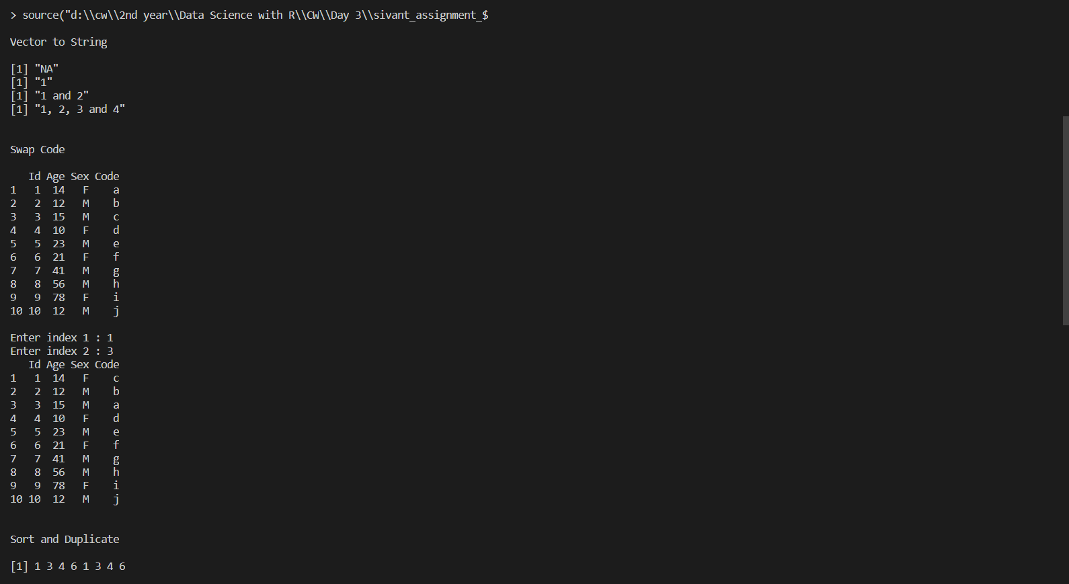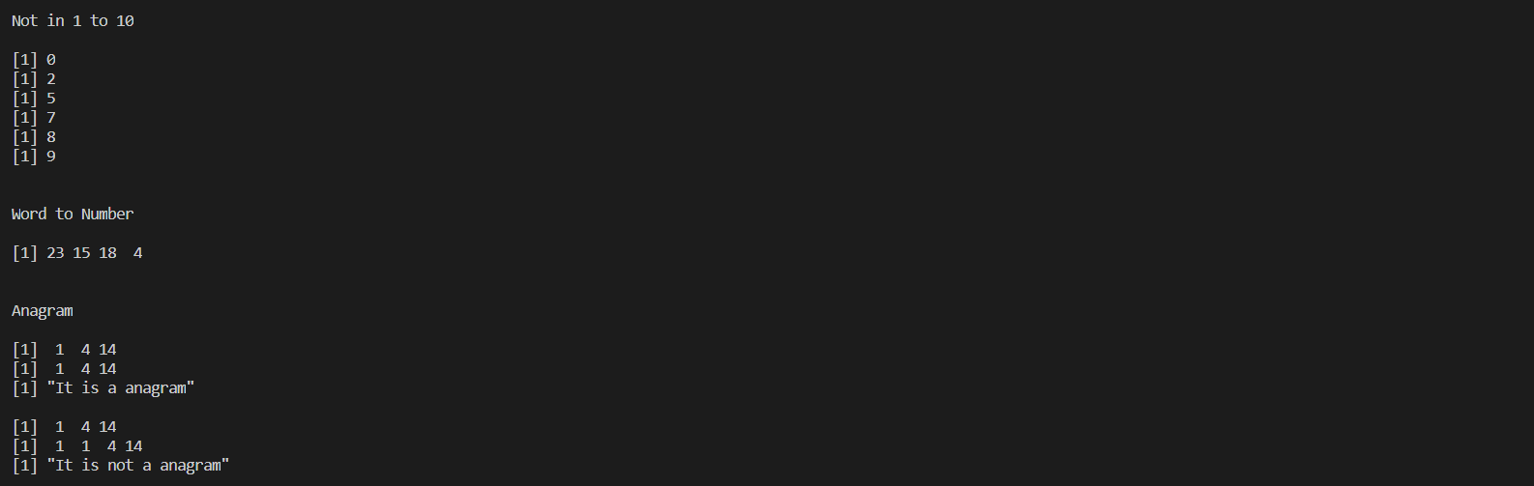

**Explanation:**

1. length():

length() is an inbuilt function which returns the length of vectors

1. grep():

grep() is an inbuilt function which returns the index of matched sequence

1. strsplit():

strsplit function in R is used to split the string into substrings with the specified delimiter.

**Syntax:** strsplit(string, delimiter)

1. match():

Match() Function in R , returns the position of match i.e. first occurrence of elements of Vector 1 in Vector 2. If an element of vector 1 doesn’t match any element of vector 2 then it returns “NA”.

**Syntax:** match(v1, v2)

1. all.equal():

Return true if all the values of vector1 (v1) and vector2 (v2) are equal

**Syntax:** all.equal(v1, v2)

**Date: 05-11-2020**

**Questions:**

1. List all example files available with the readr library.
2. Read the mtcars.csv file.
3. Read the first 10 lines from the mtcars.csv file.

**Program:**

# question 1

library(readr)

print(dir(system.file("extdata", package = "readr")))

cat('\n')

# question 2

df <- read_csv(readr_example('mtcars.csv'))

print(dim(df))

cat('\n')

# question 3

df <- read.csv(readr_example('mtcars.csv'),nrows=10)

print(df)

cat('\n')

**Output:**

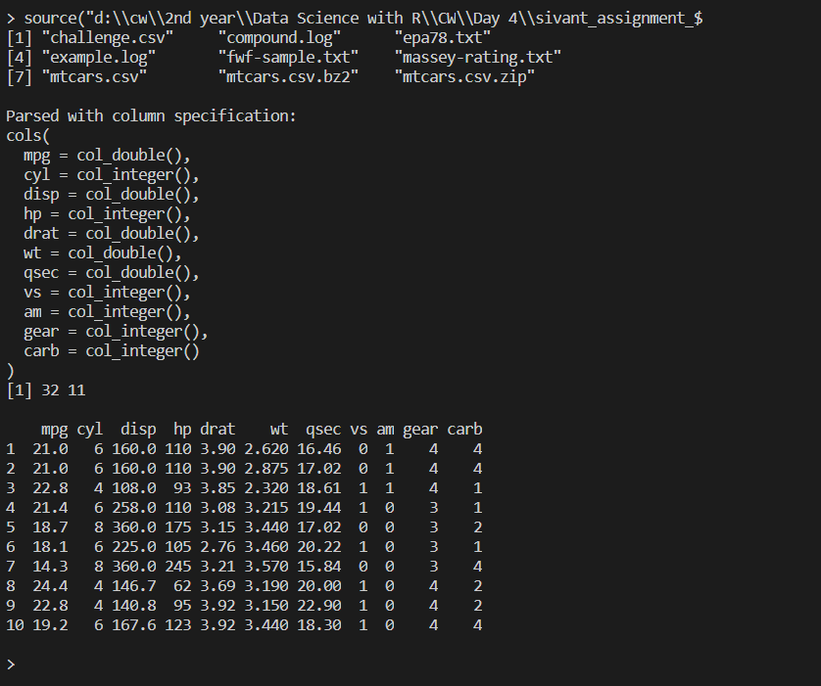

**Explanation:**

1. read.csv():

read.csv() is an inbuilt r package use to read data from csv files

1. readr_example():

readr_example is use to load example files in readr package

**Date: 05-11-2020**

**Questions:**

Perform the following visualization on movies dataset

1. Bar plot

2. Grouped bar plot

3. Line chart

4. Scatter plot

5. Pie chart and 3D pie chart

6. Histogram

7. Compare and analysis the difference plot

8. Demonstrate the ggplot2 layer

9. Draw the histogram using ggplot2

10. Demonstrate wordcloud

**Program:**

library(ggplot2)

library(ggplot2movies)

library(wordcloud)

library(plotrix)

# bar plot

count=head(movies$rating,40)

count = table(count)

barplot(count,main="Bar Plot",xlab = "Rating",ylab= "Frequency",col=c("pink"))

# double bar plot

count = table(head(movies$r9,100),head(movies$r10,100))

barplot(count,main="Double Bar Plot",beside = TRUE,xlab = "Rating",ylab= "Frequency",col=c("pink","light yellow"))

# pie chart

slices = movies$length[130:133]

pct = round((slices/sum(slices))*100)

labs = movies$title[130:133]

lbl = paste(labs,pct,"%",sep=" ")

pie(slices,lbl,main="Pie Chart",col = c("grey","pink","light blue","light yellow"))

# 3D Pie Chart

pie3D(slices,labels = paste(pct,'%'),main="Pie Chart 3D",col = c("grey","pink","light blue","light yellow"))

# bar plot

hist(movies$year,col = "pink", main="Movies Frequency", xlab="Year")

# density plot

data=density(movies$year)

plot(data,main="Movies Frequency", xlab="Year")

polygon(data,col='light yellow',border="grey")

# line plot

rating = head(movies$rating,13)

year = head(movies$year,13)

plot(y=rating,x=year,type="b",main="Line Graph")

# scatter plot

rating = head(movies$rating,30)

year = head(movies$year,30)

plot(y=rating,x=year,main="Scatter Plot", col = rep(1:2, each = 20), pch = 19)

legend("bottomright", legend = paste("Group", 1:2), col = 1:2, pch = 19, bty = "n")

# wordcloud

wordcloud(words = movies$title,freq = movies$length, min.freq = 2,max.words = 35,random.order = FALSE)

# scatter plot using ggplot

pl<-ggplot(data=head(movies,100),aes(x=rating,y=year))

pl<-pl+geom_point()

print(pl)

# histogram

mov<-ggplot(data=movies,aes(x=rating))

mov<-mov+geom_histogram(bins = 20,color = "black", fill="light yellow",alpha=1)+xlab("Movie Rating")+ylab("Movie Count")+ggtitle("Movies Plot")

print(mov)

**Output:**

**Question 1:**

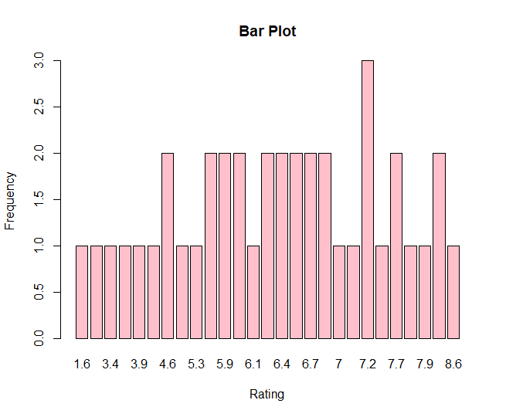

**Question 2:**

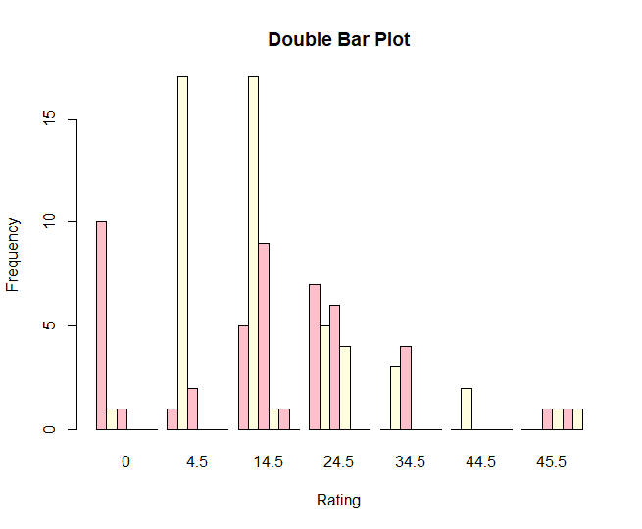

**Question 3:**

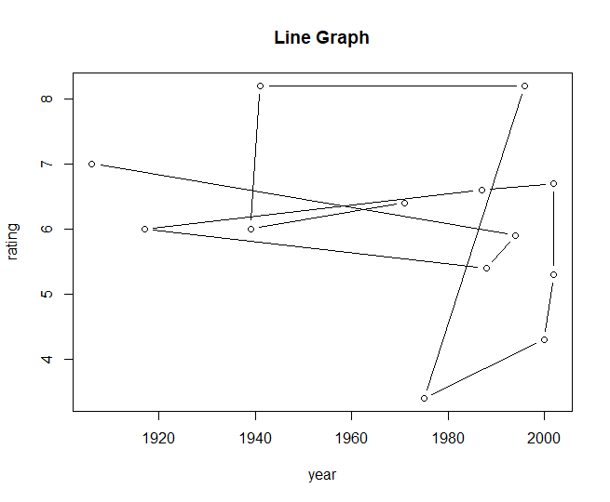

**Question 4:**

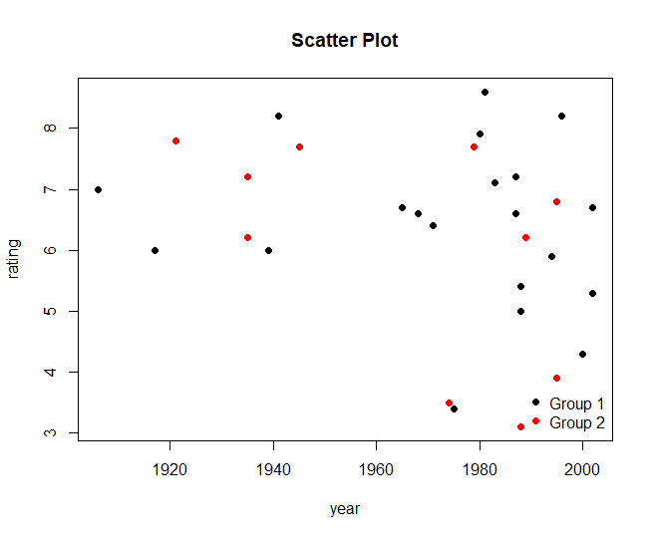

**Question 5:**

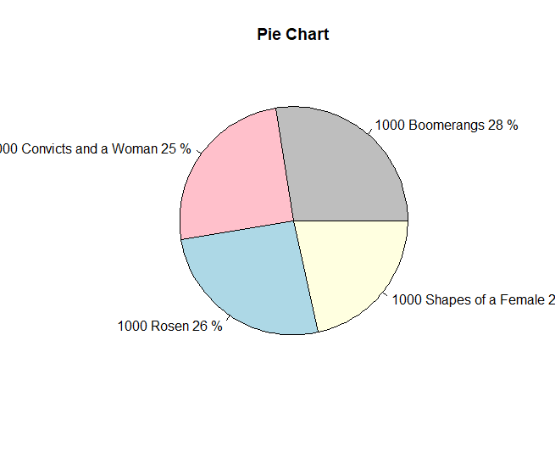

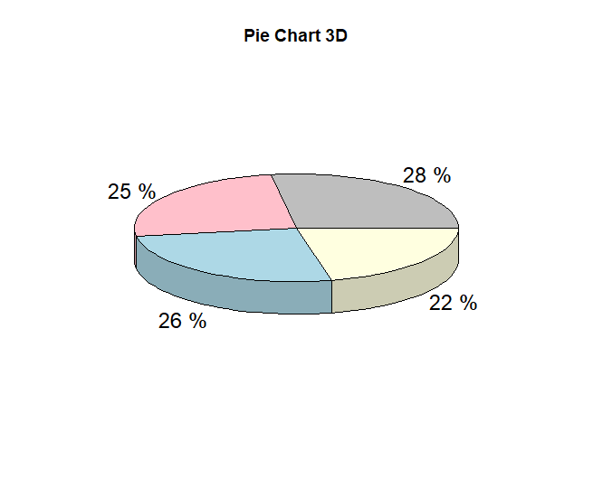

**Question 6:**

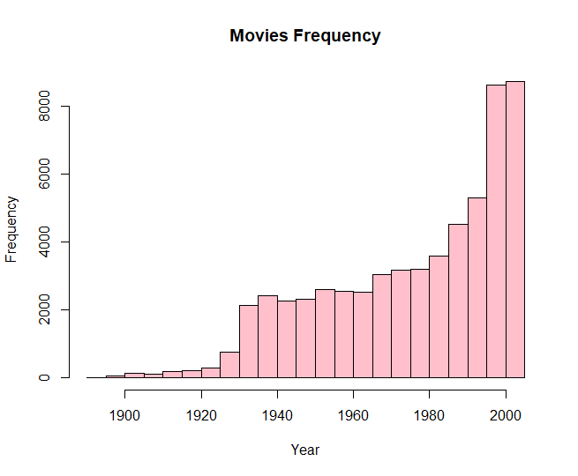

**Question 7:**

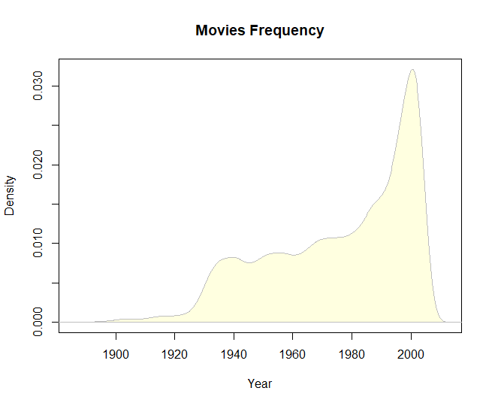

**Question 8:**

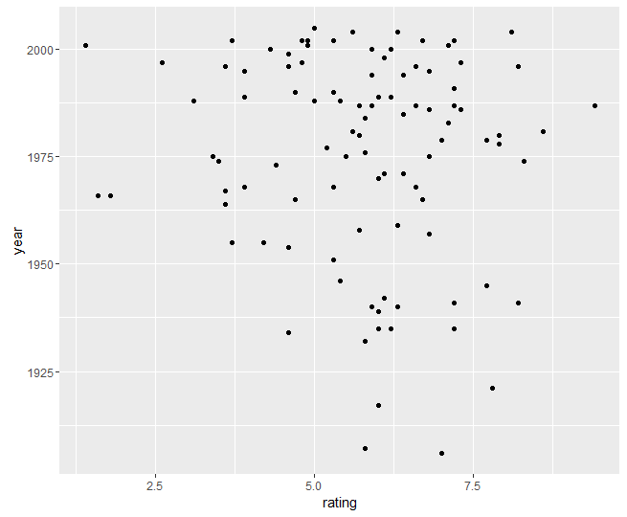

**Question 9:**

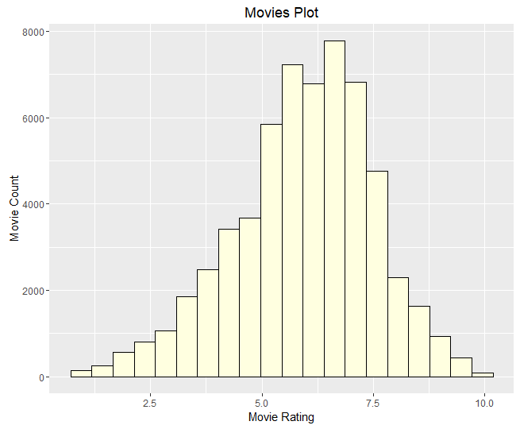

**Question 10:**

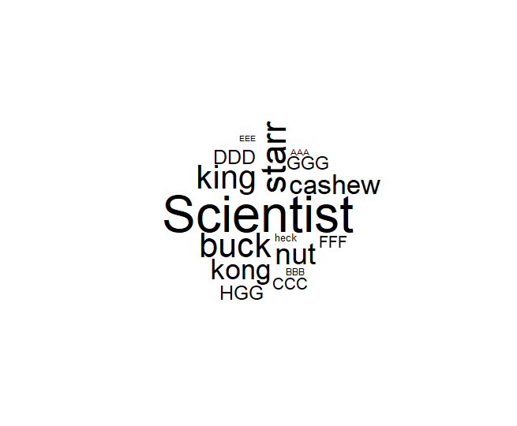

**Explanation:**

1. plot():

The plot function in R has a type argument that controls the type of plot that gets drawn.

The Help page for plot() has a list of all the different types that you can use with the type argument:

* “p”: Points
* “l”: Lines
* “b”: Both
* “c”: The lines part alone of “b”
* “o”: Both “overplotted”
* “h”: Histogram like (or high-density) vertical lines
* “n”: No plotting

1. Histogram:

A histogram plots the frequency of observations.

1. Box Plot:

A boxplot provides a graphical view of the median, quartiles, maximum, and minimum of a data set.

1. Pie Chart:

Pie charts are created with the function pie(x, labels=) where x is a non-negative numeric vector indicating the area of each slice and labels= notes a character vector of names for the slices.

1. Word cloud:

A word cloud (or tag cloud) is a text mining method to find the most frequently used words in a text